**Task Description:**

1. Get me the IP address of a particular domain (guvi.in). How do I find my CPU/memory usage of my server? Test the connectivity between 2 nodes?

**Solution:**

# finding the IP address

nslookup guvi.in

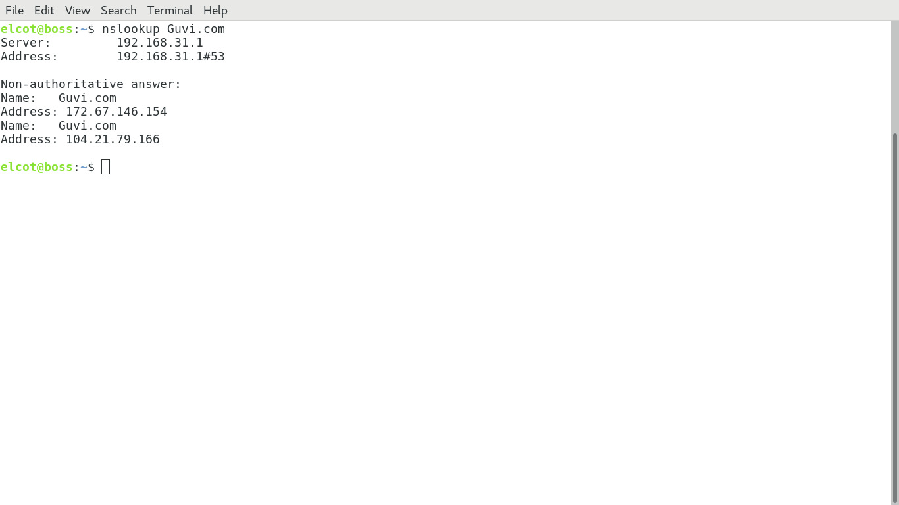

#find Cpu/memory usage

Top

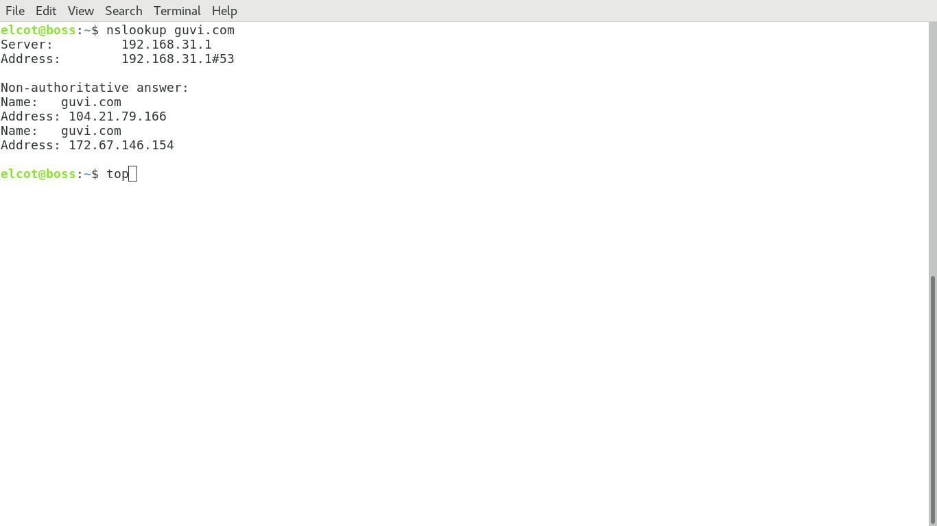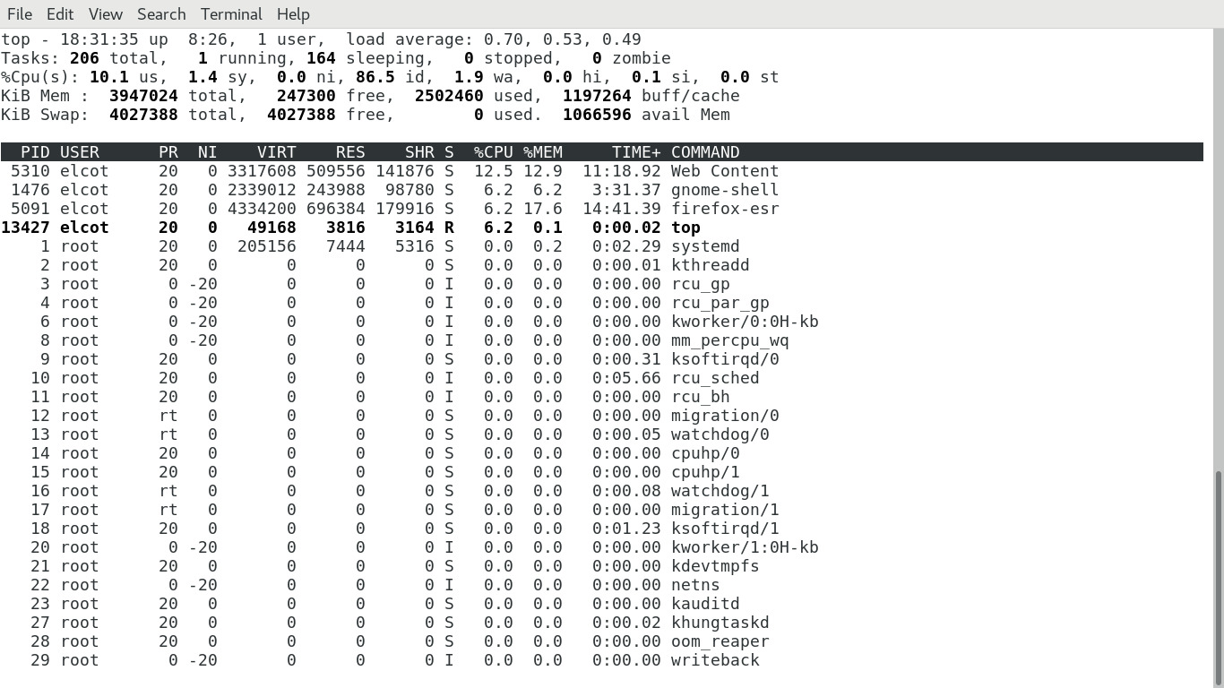

# Connectivity between two nodes

# ping Host IP(xxxx.xxxx.xxxx.xxxx)

ping 191.168.31.1

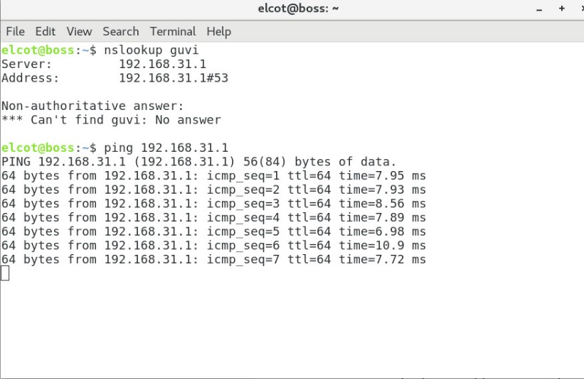

**Task Description:**

1. I have deployed an application in guvi.com:9000, and logs show my app is running, but I’m unable to view the page. Check whether my port is open or not ?

**Solution:**

sudo ss -tunl

#The command sudo ss -tuln is used to display listening network sockets on a Linux system. Here's a breakdown of the options used:

ss → A utility to investigate sockets (similar to netstat, but faster and more powerful).

-t → Show TCP sockets.

-u → Show UDP sockets.

-l → Show only listening sockets (services waiting for connections).

-n → Show numerical addresses instead of resolving hostnames.

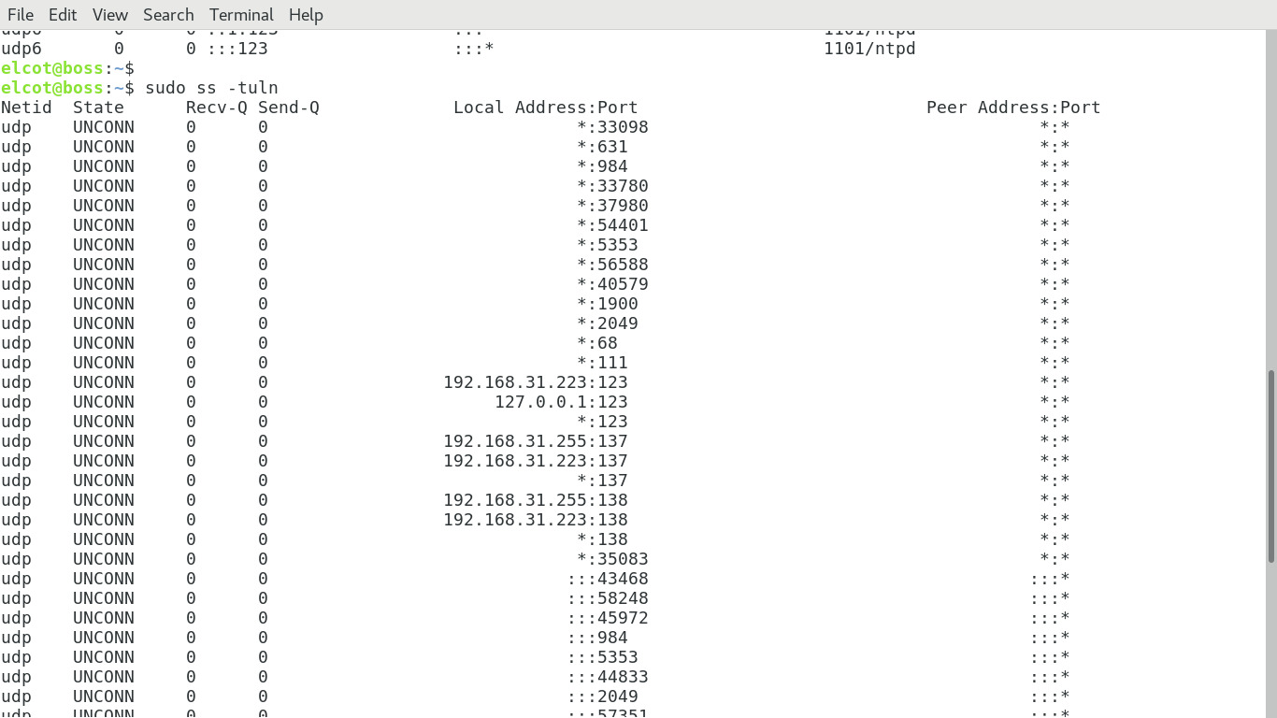 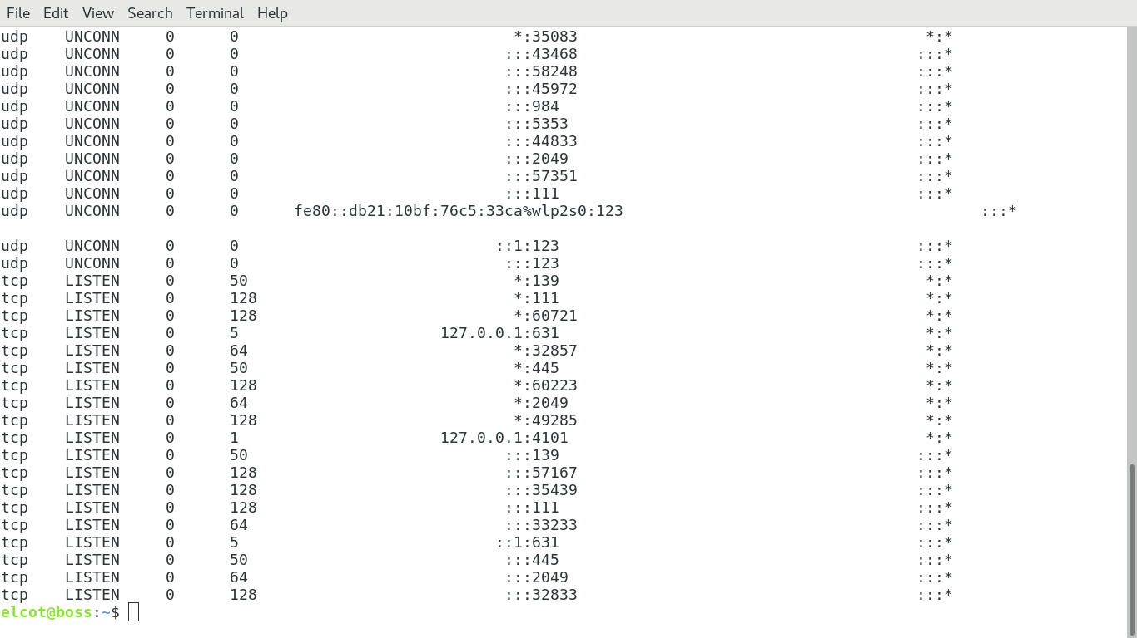

* Using the above command we can find whether port 9000 is open or not in the server.